**C programming by** [**Pritam Paul**](https://youtube.com/c/pritampaul)

**Instagram** : [**@official_pritam_paul**](https://instagram.com/official_pritam_paul) **LinkedIn :** [**Pritam Paul**](https://www.linkedin.com/company/official-pritam-paul/)

**Basics Problems:-**

1. Write a program to print 3 names in 3 different lines.
2. Write a program to print the sum, difference, multiplication, division of two numbers.
3. Write a program to input two integers and swap them (with using 3rd variable)
4. Write a program to input two integers and swap them (without using 3rd variable)
5. Write a program to input one integer and one float number and find their Sum.
6. Write a program to input one fractional number and printf the integer part and fractional part differently.
7. Write a program to input any character and print the ASCII value of that character.

**Control Statements:-**

* **If-Else**

1. Write a program to input any number and check whether it is positive or negative or zero.
2. Write a program to input any number and print “correct” if it is 10 else print “Incorrect”.
3. Write a program to input any number and check whether it is even or odd.
4. Write a program to input any year and check whether it is leap year or not.
5. Write a program to input any float number and round off the number.
6. Write a program to find the roots of a quadratic equation and find the real and imaginary roots. If the roots are real then print them else print “roots are imaginary”.
7. Write a program to check if a person is eligible to vote in India or not.
8. Write a program to input three numbers and find the smallest one (using a logical operator).
9. Write a program to input three numbers and find the smallest one (using else-if ladder).
10. Write a program to input three numbers and find the smallest one (using nested if else).
11. Write a program to input three numbers and find the smallest one (using ternary operator or conditional operator).
12. Write a program to input any character and check whether it is a vowel or not(using if statement and logical OR).
13. Write a program to input any character and check either it is capital letter or it is a small letter or it is a number.
14. Write a program to input any alphabet and print the capital letter if the character is small and print the small letter if the character is capital letter.

* **Switch Case**

1. Write a program to input any character and check whether it is a vowel or not (using a switch case).
2. Write a program to input any number and print the corresponding month using a switch case.
3. Write a program to input two integers and find their sum, difference, multiplication, division and modulus using a switch case.
4. Write a Program to input a number & print the corresponding Week day using a switch case. (week starts on Sunday)
5. Write a program to find out the number of notes required for a given amount of money. (Start by 2000 Rs Note, 500, 200, 100, 50, 20, 10, 5, 2, 1)

* **For Loop**

1. Write a program to print any name for 10 times.(using for loop)
2. Write a program to print all two digit odd numbers in reverse order.(using for loop)
3. Write a program to input ‘n’ and find the sum of n natural numbers.(using for loop)
4. Write a program to input any numbers and find the factorial of that number.(using for loop)
5. Write a Program to multiply two positive numbers without using * operator.
6. Write a Program to input an integer and find out the sum of all the digits of that number (using for loop).
7. Write a Program to input any Number and count the number of digits using for loop.
8. Write a program to input lower limit and upper limit and print all the odd numbers in that range.(using for loop)
9. Write a program to input any number and print the multiplication table of that number.(using for loop)
10. Write a program to input any number and print twenty numbers in descending order from the number.(using for loop)
11. Write a program to calculate x^y without using any library function.(using for loop)
12. Write a program to input any number and the factors of that number.(using for loop)
13. Write a program to input any number and check if it is perfect or not (factors’ sum)(using for loop).
14. Write a program to input any number and check if it is a strong number (digits’ factorials’ sum is equal to that number) or not using for loop.
15. Write a program to input any number and count the number of factors of that number.(using for loop)
16. Write a program to input any number and check it is prime or not.(using for loop)
17. Write a Program to input any number and check whether it is Armstrong Number (A three digit number in which the sum of cube of all digits is equal to the number. Eg:- 371=33+73+13) or not using for loop.
18. Write a program to print fibonacci series up to nth term.(using for loop)
19. Write a program to print fibonacci series up to n.(using for loop)
20. Write a program to input any number and check whether it is palindrome or not (using for loop).
21. write a program to input lower limit and upper limit and print the multiplication table of each number.(using for loop)
22. write a program to input lower limit and upper limit and print the factorial of each number.(using for loop)
23. write a program to input lower limit and upper limit and print the factors of each number.(using for loop)
24. write a program to input lower limit and upper limit and print the no of factors of each number.(using for loop)
25. Write a program to input lower limit and upper limit and print all the prime numbers in that range.
26. Write a Program to input lower limit and upper limit and print all the perfect numbers in that range.
27. Write a program to input lower limit and upper limit and print all the strong numbers in that range.
28. Write a program to input lower limit and upper limit and print all the armstrong numbers in that range.

**Pattern 1 : -**

**1)**

**\***

**\* \***

**\* * \***

**\* * * \***

**\* * * * \***

**2)**

**1**

**1 2**

**1 2 3**

**1 2 3 4**

**1 2 3 4 5**

**3)**

**1**

**2 2**

**3 3 3**

**4 4 4 4**

**5 5 5 5 5**

**4)**

**5**

**5 4**

**5 4 3**

**5 4 3 2**

**5 4 3 2 1**

**5)**

**5**

**4 4**

**3 3 3**

**2 2 2 2**

**1 1 1 1 1**

**6)**

**1**

**2 2**

**3 3 3**

**2 2 2 2**

**1 1 1 1 1**

**7)**

**1**

**1 2**

**1 2 3**

**1 2 3 2**

**1 2 3 2 1**

**8)**

**5**

**4 4**

**3 3 3**

**4 4 4 4**

**5 5 5 5 5**

**9)**

**5**

**5 4**

**5 4 3**

**5 4 3 4**

**5 4 3 4 5**

**10)**

**1**

**0 1**

**1 0 1**

**0 1 0 1**

**1 0 1 0 1**

**11)**

**0**

**1 0**

**0 1 0**

**1 0 1 0**

**0 1 0 1 0**

**12)**

**1**

**2 3**

**4 5 6**

**7 8 9 10**

**13)**

**A**

**B B**

**C C C**

**D D D D**

**E E E E E**

**14)**

**A**

**A B**

**A B C**

**A B C D**

**A B C D E**

**15)**

**A**

**B B**

**C C C**

**B B B B**

**A A A A A**

**16)**

**A**

**A B**

**A B C**

**A B C B**

**A B C B A**

**17)**

**A**

**B C**

**D E F**

**G H I J**

**K L M N O**

**18)**

**E**

**E D**

**E D C**

**E D C D**

**E D C D E**

**19)**

**E**

**D D**

**C C C**

**D D D D**

**E E E E E**

**Pattern 2 :**

**1)**

**\* * * * \***

**\* * * \***

**\* * \***

**\* \***

**\***

**2)**

**1 2 3 4 5**

**1 2 3 4**

**1 2 3**

**1 2**

**1**

**3)**

**1 1 1 1 1**

**2 2 2 2**

**3 3 3**

**4 4**

**5**

**4)**

**5 5 5 5 5**

**4 4 4 4**

**3 3 3**

**2 2**

**1**

**5)**

**5 4 3 2 1**

**5 4 3 2**

**5 4 3**

**5 4**

**5**

**6)**

**1 2 3 2 1**

**1 2 3 2**

**1 2 3**

**1 2**

**1**

**7)**

**1 1 1 1 1**

**2 2 2 2**

**3 3 3**

**2 2**

**1**

**8)**

**A B C D E**

**A B C D**

**A B C**

**A B**

**A**

**9)**

**A A A A A**

**B B B B**

**C C C**

**D D**

**E**

**10)**

**A B C B A**

**A B C B**

**A B C**

**A B**

**A**

**11)**

**A A A A A**

**B B B B**

**C C C**

**B B**

**A**

**12)**

**A B C D E**

**F G H I**

**J K L**

**M N**

**O**

**13)**

**5 4 3 4 5**

**5 4 3 4**

**5 4 3**

**5 4**

**5**

**14)**

**5 5 5 5 5**

**4 4 4 4**

**3 3 3**

**4 4**

**5**

**15)**

**1 0 1 0 1**

**0 1 0 1**

**1 0 1**

**0 1**

**1**

**16)**

**A A A A A**

**E E E E**

**I I I**

**M M**

**Q**

**17)**

**A E I M Q**

**A E I M**

**A E I**

**A E**

**A**

**18)**

**E D C D E**

**E D C D**

**E D C**

**E D**

**E**

**19)**

**E E E E E**

**D D D D**

**C C C**

**D D**

**E**

**Pattern 3 : -**

**1)**

**\***

**\* \***

**\* * \***

**\* * * \***

**\* * * * \***

**2)**

**1**

**1 2**

**1 2 3**

**1 2 3 4**

**1 2 3 4 5**

**3)**

**1**

**2 2**

**3 3 3**

**4 4 4 4**

**5 5 5 5 5**

**4)**

**1**

**2 2**

**3 3 3**

**2 2 2 2**

**1 1 1 1 1**

**5)**

**1**

**1 2**

**1 2 3**

**1 2 3 2**

**1 2 3 2 1**

**6)**

**1**

**0 1**

**1 0 1**

**0 1 0 1**

**1 0 1 0 1**

**7)**

**0**

**1 0**

**0 1 0**

**1 0 1 0**

**0 1 0 1 0**

**8)**

**1**

**1 0**

**1 0 1**

**1 0 1 0**

**1 0 1 0 1**

**9)**

**A**

**A B**

**A B C**

**A B C D**

**A B C D E**

**10)**

**A**

**B B**

**C C C**

**D D D D**

**E E E E E**

**11)**

**A**

**B B**

**C C C**

**B B B B**

**A A A A A**

**12)**

**A**

**B C**

**D E F**

**G H I J**

**K L M N O**

**13)**

**1**

**2 3**

**4 5 6**

**7 8 9 10**

**11 12 13 14 15**

**Pattern 4 : -**

**1)**

**\* * * * \***

**\* * * \***

**\* * \***

**\* \***

**\***

**2)**

**1 2 3 4 5**

**1 2 3 4**

**1 2 3**

**1 2**

**1**

**3)**

**5 5 5 5 5**

**4 4 4 4**

**3 3 3**

**2 2**

**1**

**4)**

**1 1 1 1 1**

**2 2 2 2**

**3 3 3**

**2 2**

**1**

**5)**

**1 2 3 2 1**

**1 2 3 2**

**1 2 3**

**1 2**

**1**

**6)**

**1 0 1 0 1**

**0 1 0 1**

**1 0 1**

**0 1**

**1**

**7)**

**0 1 0 1 0**

**1 0 1 0**

**0 1 0**

**1 0**

**0**

**8)**

**1 0 1 0 1**

**1 0 1 0**

**1 0 1**

**1 0**

**1**

**9)**

**A B C D E**

**A B C D**

**A B C**

**A B**

**A**

**10)**

**E E E E E**

**D D D D**

**C C C**

**B B**

**A**

**11)**

**A A A A A**

**B B B B**

**C C C**

**B B**

**A**

**12)**

**K L M N O**

**G H I J**

**D E F**

**B C**

**A**

**13)**

**11 12 13 14 15**

**7 8 9 10**

**4 5 6**

**2 3**

**1**

**WHILE :-**

1. Write a program to print the first ‘n’ natural number in ascending and descending order.(using while loop)
2. Write a program to input any number ‘n’ and printf the sum of n natural numbers .(using while loop)
3. Write a program to input any number and print the factorial of that number(using while loop)
4. Write a program to input any number & print 20 numbers in descending order from that number.(using while loop)
5. Write a program to input lower limit and upper limit and print all the odd numbers in that range.(using while loop)
6. Write a program to input any number and print the multiplication table of that number.(using while loop)
7. Write a program to calculate x^y without using any library function(using while loop)
8. Write a program to input any number and the factors of that number(using while loop)
9. Write a program to input any number and check it is perfect or not(factors’ sum)(using while loop)
10. Write a program to input any number and check it is prime or not.(using while loop)
11. Write a program to input any number and count the number of factors of that number.(using while loop)
12. write a program to input lower limit and upper limit and print the multiplication table of each number.(using while loop)
13. write a program to input lower limit and upper limit and print the factorial of each number.(using while loop)
14. write a program to input lower limit and upper limit and print the factors of each number.(using while loop)
15. write a program to input lower limit and upper limit and print the no of factors of each number.(using while loop)
16. Write a program to print fibonacci series upto nth term.(using while loop)
17. Write a program to print fibonacci series upto n.(using while loop)
18. Write a program to input any number and check whether it is palindrome or not(using while loop)
19. Write a program to input any number 'n' and digit 'd' also and check the frequency of d in n.
20. Write a program to input any number and check it is strong number or not.(using while)
21. Write a program to input any number and check whether it is a power of 2 or not. (using while loop)
22. Write a program to input any number and check whether it is a power of 2 or not. (using bitwise operator)

**DO-WHILE** :-

1. Write a program to input any number and check whether it is palindrome or not(using do-while loop)
2. Write a program to input any number and check it is strong number or not.(using do-while)
3. Write a program to input any number and count the prime digits(using do-while)
4. Write a program to input any number and replace all the prime digits by 1(using do-while)
5. Write a program to input any number and find the sum of the digits of that number.(using do-while loop)
6. Write a program to input any number and find the sum of the digits of that number until you get a single digit.(using do-while loop)

**Function Call by Value:-**

1. Write a program to input two numbers and print the sum, difference, multiplication, division of those numbers using call by value with return. (use different functions for different operation)
2. Write a program to input any float and round off of that float using call by value with return.
3. Write a program to input any float number and print the integer part and float part differently using function call by value with return.
4. Write a program to input any character and print the ASCII value of that character using function by value with return.
5. Write a program to input any number and check whether it is positive or negative or zero using function call by value with return.
6. Write a program to input any number and print “correct” if it is 10 else print “Incorrect” using function call by value with return.
7. Write a program to input any number and check whether it is even or odd using function call by value with return.
8. Write a program to input any year and check whether it is leap year or not using function call by value with return.
9. Write a program to input any float number and round off the number using function call by value with return.
10. Write a program to check if a person is eligible to vote in India or not using function call by value with return.
11. Write a program to input three numbers and find the smallest one (using a logical operator) using function call by value with return.
12. Write a program to input three numbers and find the smallest one (using else-if ladder) using function call by value with return.
13. Write a program to input three numbers and find the smallest one (using nested if else) using function call by value with return.
14. Write a program to input three numbers and find the smallest one (using ternary operator or conditional operator) using function call by value without return.
15. Write a program to input any float number and print the integer part and float part differently using function call by value without return.
16. Write a program to input any character and check whether it is a vowel or not(using if statement and logical OR) using function call by value with return.
17. Write a program to input any character and check either it is capital letter or it is a small letter or it is a number using function call by value with return.
18. Write a program to print all two digit odd numbers in reverse order using call by value without return.
19. Write a program to input ‘n’ and find the sum of n natural numbers using call by value with return.
20. Write a program to input any numbers and find the factorial of that number using call by value with return.
21. Write a Program to multiply two positive numbers without using * operator using call by value with return.
22. Write a Program to input an integer and find out the sum of all the digits of that number using call by value with return.
23. Write a Program to input any Number and count the number of digits using call by value with return.
24. Write a program to input lower limit and upper limit and print all the odd numbers in that range using call by value without return.
25. Write a program to input any number and print the multiplication table of that number using call by value without return.
26. Write a program to input any number and print twenty numbers in descending order from the number using call by value without return.
27. Write a program to calculate x^y without using any library function using call by value with return.
28. Write a program to input any number and the factors of that number using call by value without return.
29. Write a program to input any number and check if it is perfect or not (factors’ sum using call by value with) using function call by value with return.
30. Write a program to input any number and check if it is a strong number (digits’ factorials’ sum is equal to that number) using function call by value with return.
31. Write a program to input any number and count the number of factors of that number using call by value with return.
32. Write a program to input any number and check it is prime or not using call by value with return.
33. Write a Program to input any number and check whether it is Armstrong Number (A three digit number in which the sum of cube of all digits is equal to the number. Eg:- 371=33+73+13) or not using function call by value with return.
34. Write a program to print fibonacci series up to the nth term using call by value without return.
35. Write a program to print fibonacci series up to n using call by value without return.
36. Write a program to input any number and check whether it is palindrome or not using call by value with return.
37. write a program to input lower limit and upper limit and print the multiplication table of each number using call by value with/without(whatever you want) return.
38. write a program to input lower limit and upper limit and print the factorial of each number using call by value with/without(whatever you want) return.
39. write a program to input lower limit and upper limit and print the factors of each number using call by value with/without(whatever you want) return.
40. write a program to input lower limit and upper limit and print the number of factors of each number using call by value with/without(whatever you want) return.
41. Write a program to input lower limit and upper limit and print all the prime numbers in that range using function call by value with/without(whatever you want) return.
42. Write a Program to input lower limit and upper limit and print all the perfect numbers in that range using function call by value with/without(whatever you want) return.
43. Write a program to input lower limit and upper limit and print all the strong numbers in that range using function call by value with/without(whatever you want) return.
44. Write a program to input lower limit and upper limit and print all the armstrong numbers in that range using function call by value with/without(whatever you want) return.
45. Write a program to input any number 'n' and digit 'd' also and check the frequency of d in n using function call by value with return.

**Recursion:-**

1. WAP to input any number and find it’s factorial using recursion.
2. WAP to input any number ‘n’ and find the sum of n natural numbers using recursion.
3. WAP to input any number ‘n’ and print all the numbers from 1 to n using recursion.
4. WAP to input any number ‘n’ and find the sum of n natural numbers using recursion abd print the series with result.
5. WAP to input any number and find the sum of all the digits using recursion.
6. WAP to input any decimal number and convert the number to binary, octal and hexadecimal using recursion.
7. WAP to input any float number (base) and an integer (power) and calculate the value using recursion.
8. WAP to input any number and find it’s prime factors using recursion.
9. WAP to input any two numbers and find their GCD using recursion.
10. WAP to input any number N print fibonacci series unto Nth term using recursion.
11. WAP to input any number ‘N’ and check either it is divisible by 11 or not using recursion.
12. WAP to input any number ‘N’ and check either it is divisible by 9 or not using recursion.
13. WAP to input any number and reverse it using recursion.
14. WAP to input any number N and find the sum of the below expression:-

$x-{(x}^{3}/3!)+(x^{5}/5!)-{(x}^{7}/7!)+(x^{9}/9!)- ................. x^{(2n-1)}/(2n-1)!$

**Findout the Output :-**

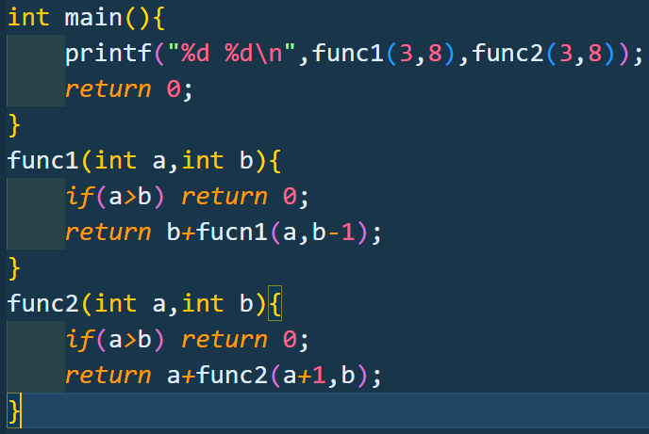 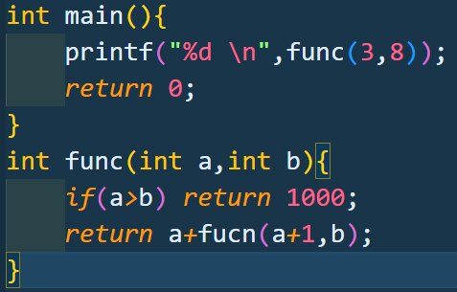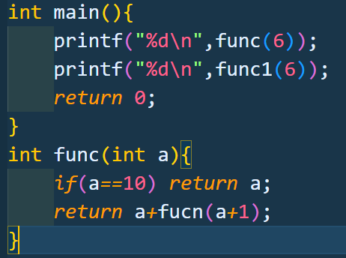

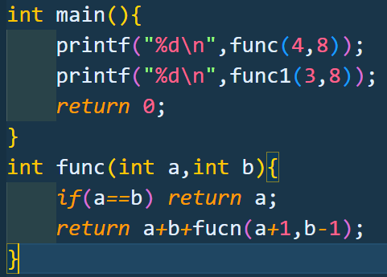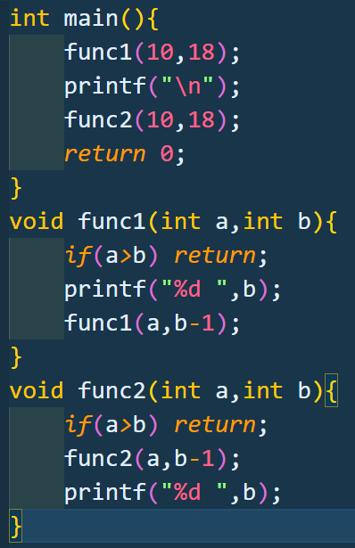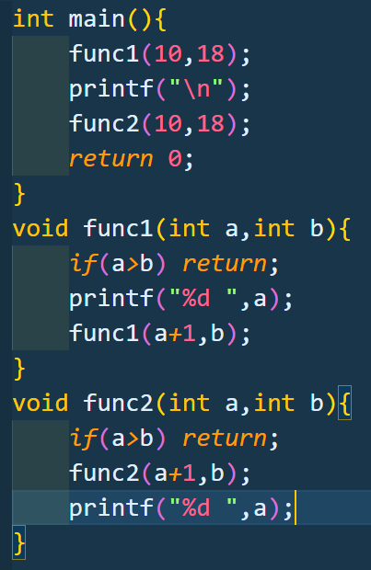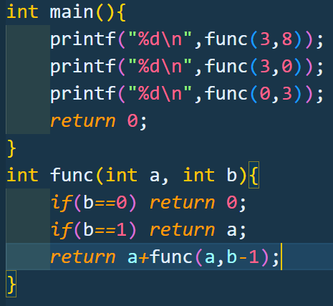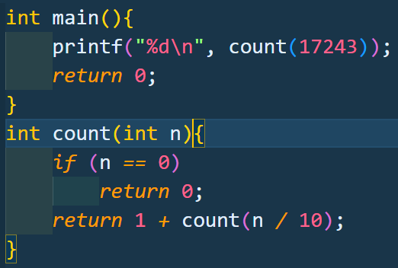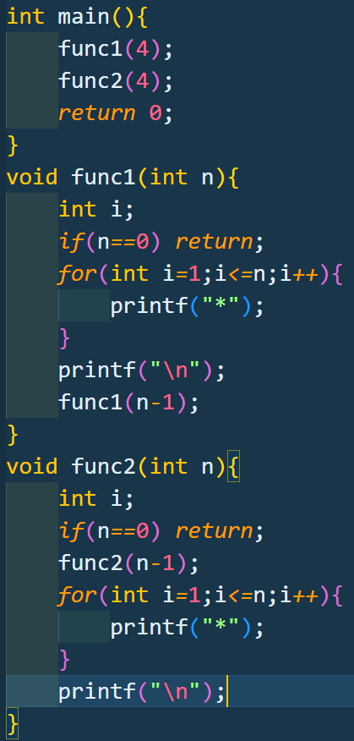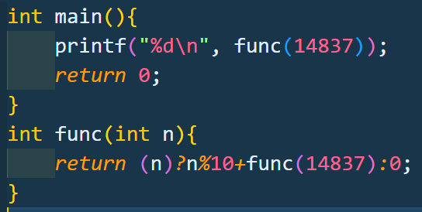 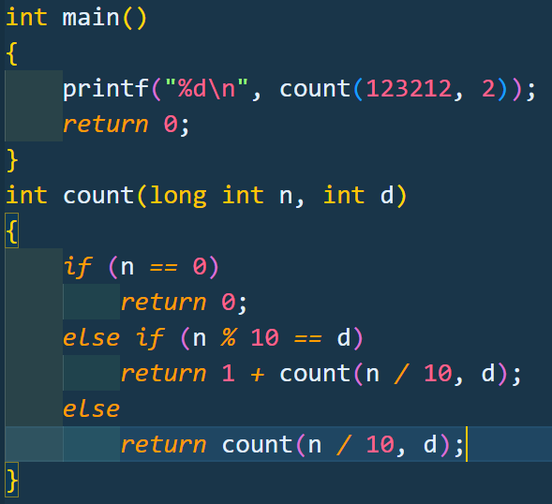

**Array:-**

1. WAP to input 10 integers in an 1-D array and print them.
2. WAP to input 10 integers in an 1-D array and find the sum of all the numbers in the array.
3. WAP to input 10 integers in an 1-D array and find the smallest one.
4. WAP to input 10 integers in an 1-D array and find the smallest one using function call by value with return.
5. WAP to input 10 integers in an 1-D array and find the biggest one.
6. WAP to input 10 integers in an 1-D array and find the biggest one using function call by value with return.
7. WAP to input 10 integers in an 1-D array and find the mean of all the elements using call by value with return.
8. WAP to input 10 integers in an 1-D array and add one element at the beginning of the array and then print the new array.
9. WAP to input 10 integers in an 1-D array and add one element at the end of the array and print the new array.
10. WAP to input 10 integers in an 1-D array and add one element at any position(take it as input) and print the new array.
11. WAP to input 10 integers in an 1-D array and delete one element from the beginning of the array and print the new array.
12. WAP to input 10 integers in an 1-D array and delete one element from the ending of the array and print the new array.
13. WAP to input 10 integers in an 1-D array and delete one element from any position (take it as input) of the array and print the new array.
14. WAP to input 10 elements in an 1-D array and count the number of even and odd numbers in that array.
15. WAP to input 10 elements in an 1-D array and reverse the array.
16. WAP to input any decimal number then convert it into a binary number (use array to store the binary number).
17. WAP to input 10 elements in an 1-D array and print the multiplication table of each number.
18. WAP to input 10 integers in an 1-D array & print the factorial of each number.
19. WAP to input 10 elements in an 1-D array and print the multiplication table of each number using function call by value without return.
20. WAP to input 10 integers in an 1-D array & print the factorial of each number using function call by value with return.
21. WAP to input 10 numbers in an 1-D array and print the factors of each number using function call by value without return.
22. WAP to input 10 numbers in an 1-D array and count the number of factors of each number using function call by value with return.
23. WAP to input 10 integers in an 1-D array & check the number of strong numbers in that array using function call by value with return.
24. WAP to input 10 integers in an 1-D array & check the number of perfect numbers in that array using function call by value with return.
25. WAP to input 10 integers in an 1-D array and print the sum of digits of all the numbers using function call by value with return.
26. WAP to input 10 integers in an 1-D array and count the number of prime numbers in the array using function call by value with return.
27. WAP to input 10 characters in an 1-D array and count the number of vowels using function call by value without return.
28. WAP to input 10 characters in an 1-D array and count the number of Capital letters and small letters using function call by value without return.
29. WAP to input 10 characters in an 1-D array and convert the small letters into capital letters & convert capital letters into small letters.

**2-D Array :-**

1. WAP to input the number of ROWs and Columns and input the elements and then print the 2-D array.
2. WAP to input any 3X3 matrix and find the biggest number in it.
3. WAP to input any 3X3 matrix and find the smallest number in it.
4. WAP to input any two 3X3 matrices and add them and store the resultant matrix into another one.
5. WAP to input any two 3X3 matrices and subtract them and store the resultant matrix into another one.
6. WAP to input any 3X3 matrix and transpose it.

**Function Call by Value:-**

1. Write a program to input two numbers and print the sum, difference, multiplication, division of those numbers using call by value with return. (use different functions for different operation)
2. Write a program to input any float and round off of that float using call by value with return.
3. Write a program to input any float number and print the integer part and float part differently using function call by value without return.
4. Write a program to input any character and print the ASCII value of that character using function by value with return.
5. Write a program to input any number and check whether it is positive or negative or zero using function call by value with return.
6. Write a program to input any number and print “correct” if it is 10 else print “Incorrect” using function call by value with return.
7. Write a program to input any number and check whether it is even or odd using function call by value with return.
8. Write a program to input any year and check whether it is leap year or not using function call by value with return.
9. Write a program to input any float number and round off the number using function call by value with return.
10. Write a program to check if a person is eligible to vote in India or not using function call by value with return.
11. Write a program to input three numbers and find the smallest one (using a logical operator) using function call by value with return.
12. Write a program to input three numbers and find the smallest one (using else-if ladder) using function call by value with return.
13. Write a program to input three numbers and find the smallest one (using nested if else) using function call by value with return.
14. Write a program to input three numbers and find the smallest one (using ternary operator or conditional operator) using function call by value without return.
15. Write a program to input any character and check whether it is a vowel or not(using if statement and logical OR) using function call by value with return.
16. Write a program to input any character and check either it is capital letter or it is a small letter or it is a number using function call by value with return.
17. Write a program to print all two digit odd numbers in reverse order using call by value without return.
18. Write a program to input ‘n’ and find the sum of n natural numbers using call by value with return.
19. Write a program to input any numbers and find the factorial of that number using call by value with return.
20. Write a Program to multiply two positive numbers without using * operator using call by value with return.
21. Write a Program to input an integer and find out the sum of all the digits of that number using call by value with return.
22. Write a Program to input any Number and count the number of digits using call by value with return.
23. Write a program to input lower limit and upper limit and print all the odd numbers in that range using call by value without return.
24. Write a program to input any number and print the multiplication table of that number using call by value without return.
25. Write a program to input any number and print twenty numbers in descending order from the number using call by value without return.
26. Write a program to calculate x^y without using any library function using call by value with return.
27. Write a program to input any number and the factors of that number using call by value without return.
28. Write a program to input any number and check if it is perfect or not (factors’ sum using call by value with) using function call by value with return.
29. Write a program to input any number and check if it is a strong number (digits’ factorials’ sum is equal to that number) using function call by value with return.
30. Write a program to input any number and count the number of factors of that number using call by value with return.
31. Write a program to input any number and check it is prime or not using call by value with return.
32. Write a Program to input any number and check whether it is Armstrong Number (A three digit number in which the sum of cube of all digits is equal to the number. Eg:- 371=33+73+13) or not using function call by value with return.
33. Write a program to print fibonacci series up to the nth term using call by value without return.
34. Write a program to print fibonacci series up to n using call by value without return.
35. Write a program to input any number and check whether it is palindrome or not using call by value with return.
36. write a program to input lower limit and upper limit and print the multiplication table of each number using call by value with/without(whatever you want) return.
37. write a program to input lower limit and upper limit and print the factorial of each number using call by value with/without(whatever you want) return.
38. write a program to input lower limit and upper limit and print the factors of each number using call by value with/without(whatever you want) return.
39. write a program to input lower limit and upper limit and print the number of factors of each number using call by value with/without(whatever you want) return.
40. Write a program to input lower limit and upper limit and print all the prime numbers in that range using function call by value with/without(whatever you want) return.
41. Write a Program to input lower limit and upper limit and print all the perfect numbers in that range using function call by value with/without(whatever you want) return.
42. Write a program to input lower limit and upper limit and print all the strong numbers in that range using function call by value with/without(whatever you want) return.
43. Write a program to input lower limit and upper limit and print all the armstrong numbers in that range using function call by value with/without(whatever you want) return.
44. Write a program to input any number 'n' and digit 'd' also and check the frequency of d in n using function call by value with return.

**String :-**

1. Write a Program to initialize any string & print it.
2. Write a Program to input any string & print the values and addresses of each character in the string.
3. Write a Program to input any string & print it using scanf() & printf().
4. Write a Program to input any string & print it using gets() & puts().
5. Write a Program to input any string & find the length of the string without using any library function.
6. Write a Program to input any string & find the length of the string using library function.
7. Write a Program to input any two strings & print either they are same or not without using any library function.
8. Write a Program to input any two strings & print either they are same or not using library function.
9. Write a Program to input any string & copy the string into another string without using any library function.
10. Write a Program to input any string & copy the string into another string using the library function.
11. Write a Program to input any two strings & concatenate them without any library function.
12. Write a Program to input any two strings & concatenate them using the library function.
13. Write a Program to input any string & count the number of small letters, capital letters, numbers and other characters.